**Objectives:**

* Solve trigonometry questions, relating to **right triangles**, using these ratios:

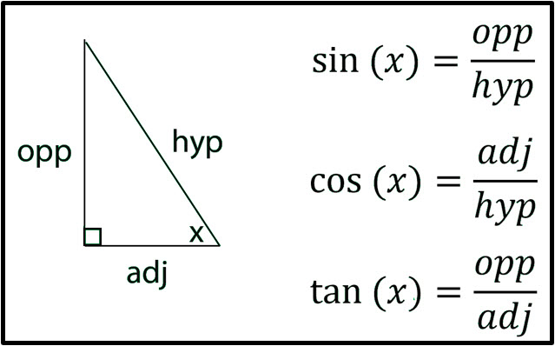

* Use the inverse sine (arcsin), inverse cosine (arccos), and inverse tangent(arctan) to find the measure of an angle in a triangle.
* Know that an **oblique** triangle is a triangle that does **not** contain a right angle.
* Use the **Law of Sines** to solve a right triangle **or** an oblique triangle when given AAS, ASA, or SSA (Ambiguous Case).

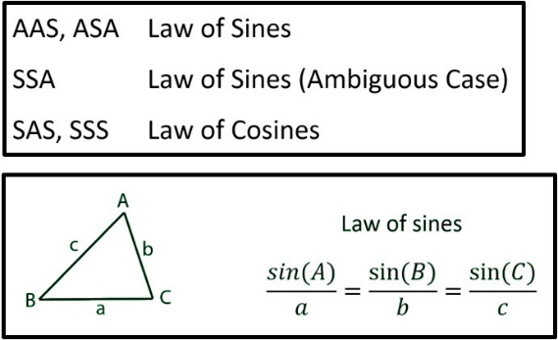

* Use the **Law of Cosines** to solve a right triangle **or** an oblique triangle when given SAS or SSS.

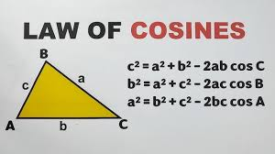

* Be able to find the areas of both right and oblique triangles.
* Use Area = 0.5(base)(height) for right triangles and oblique triangles when you know the base and the height.
* Use The Law of Sines Area Formula for oblique triangles when you know 2 sides and an included angle (SAS).
* Use Hero’s (Heron’s) Formula when you know all 3 sides (SSS).
* Know that π radians = 180o. Be able to convert radians to degrees and degrees to radians.

**Monday (3.24.25)**

**Turn in your Take-Home Project.** *Finding the Area.* (Be sure to show your work).

**Class Work:**

* Discuss the relationship between radians and degrees: π radians = 180o. Be able to convert radians to degrees and degrees to radians.
* Know that 1 radian ≈ 57.3o.
* Convert the following degrees to radians. Give exact answers, leaving π in your answers:

1. 165o
2. 232o
3. -82o
4. 354o
5. 24o12’32”

* Convert the following radians to degree, rounding to the nearest tenth.

1. π/2
2. π/3
3. π/4
4. π/6
5. 2π/3
6. 2.4
7. -3.1
8. 3π

**Class Work/Homework: Trig Review (Handout to be received in class).**

**WEDNESDAY (3.26.25)**

**Discuss the previously assigned Trig Review.**

**Study for a Trig Test to be taken on Wednesday, April 2.**

**Friday, 3.28.25 NO CLASS, SENIOR PROJECT PRESENTATIONS**